Types of Circuit Board
If you are building a project from this website or a magazine the type of circuit board will have been decided for you. The three most important types are described below:

Breadboard
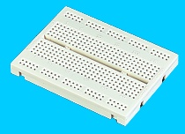
Photograph © Rapid Electronics
Temporary, no soldering required
This is a way of making a temporary circuit, for testing purposes or to try out an idea. No soldering is required and all the components can be re-used afterwards. It is easy to change connections and replace components. Almost all the Electronics Club projects started life on a breadboard to check that the circuit worked as intended.
For further details please see the Breadboard page.

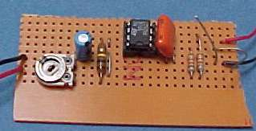
Stripboard
Permanent, soldered
Stripboard has parallel strips of copper track on one side. The strips are 0.1" (2.54mm) apart and there are holes every 0.1" (2.54mm). Stripboard requires no special preparation other than cutting to size. It can be cut with a junior hacksaw, or simply snap it along the lines of holes by putting it over the edge of a bench or table and pushing hard.
For further details please see the Stripboard page.

Printed Circuit Board
Permanent, soldered
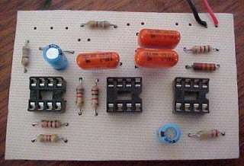
Printed circuit boards have copper tracks connecting the holes where the components are placed. They are designed specially for each circuit and make construction very easy. However, producing the PCB requires special equipment so this method is not recommended if you are a beginner unless the PCB is provided for you.
For further details please see the Printed Circuit Board page.

Soldering Guide

How to Solder

First a few safety precautions:
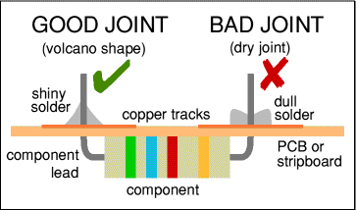
- Never touch the element or tip of the soldering iron.
They are very hot (about 400°C) and will give you a nasty burn.
- Take great care to avoid touching the mains flex with the tip of the iron.
The iron should have a heatproof flex for extra protection. An ordinary plastic flex will melt immediately if touched by a hot iron and there is a serious risk of burns and electric shock.
- Always return the soldering iron to its stand when not in use.
Never put it down on your workbench, even for a moment!
- Work in a well-ventilated area.
The smoke formed as you melt solder is mostly from the flux and quite irritating. Avoid breathing it by keeping you head to the side of, not above, your work.
- Wash your hands after using solder.
Solder contains lead which is a poisonous metal.

Preparing the soldering iron:
- Place the soldering iron in its stand and plug in.
The iron will take a few minutes to reach its operating temperature of about 400°C.
- Dampen the sponge in the stand.
The best way to do this is to lift it out the stand and hold it under a cold tap for a moment, then squeeze to remove excess water. It should be damp, not dripping wet.
- Wait a few minutes for the soldering iron to warm up.
You can check if it is ready by trying to melt a little solder on the tip.
- Wipe the tip of the iron on the damp sponge.
This will clean the tip.
- Melt a little solder on the tip of the iron.
This is called 'tinning' and it will help the heat to flow from the iron's tip to the joint. It only needs to be done when you plug in the iron, and occasionally while soldering if you need to wipe the tip clean on the sponge.

You are now ready to start soldering:
- Hold the soldering iron like a pen, near the base of the handle.
Imagine you are going to write your name! Remember to never touch the hot element or tip.
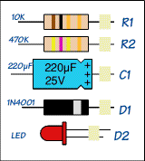
- Touch the soldering iron onto the joint to be made.
Make sure it touches both the component lead and the track. Hold the tip there for a few seconds and...
- Feed a little solder onto the joint.
It should flow smoothly onto the lead and track to form a volcano shape as shown in the diagram. Apply the solder to the joint, not the iron.
- Remove the solder, then the iron, while keeping the joint still.
Allow the joint a few seconds to cool before you move the circuit board.
- Inspect the joint closely.
It should look shiny and have a 'volcano' shape. If not, you will need to reheat it and feed in a little more solder. This time ensure that both the lead and track are heated fully before applying solder.
If you are unlucky (or careless!) enough to burn yourself please read the First Aid section.

Using a heat sink
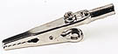
Crocodile clip
Photograph © Rapid Electronics
Some components, such as transistors, can be damaged by heat when soldering so if you are not an expert it is wise to use a heat sink clipped to the lead between the joint and the component body. You can buy a special tool, but a standard crocodile clip works just as well and is cheaper.

Soldering Advice for Components
It is very tempting to start soldering components onto the circuit board straight away, but please take time to identify all the parts first. You are much less likely to make a mistake if you do this!
- Stick all the components onto a sheet of paper using sticky tape.
- Identify each component and write its name or value beside it.
- Add the code (R1, R2, C1 etc.) if necessary.
Many projects from books and magazines label the components with codes (R1, R2, C1, D1 etc.) and you should use the project's parts list to find these codes if they are given.
- Resistor values can be found using the resistor colour code which is explained on our Resistors page. You can print out and make your own Resistor Colour Code Calculator to help you.
- Capacitor values can be difficult to find because there are many types with different labelling systems! The various systems are explained on our Capacitors page.
Some components require special care when soldering. Many must be placed the correct way round and a few are easily damaged by the heat from soldering. Appropriate warnings are given in the table below, together with other advice which may be useful when soldering.
For more detail on specific components please see the Components page or click on the component name in the table.
For most projects it is best to put the components onto the board in the order given below:
 | Components | Pictures | Reminders and Warnings
1 | IC Holders  (DIL sockets) | 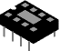 | Connect the correct way round by making sure the notch is at the correct end.  Do NOT put the ICs (chips) in yet.
2 | Resistors |  | No special precautions are needed with resistors.
3 | Small value capacitors  (usually less than 1µF) | 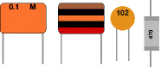 | These may be connected either way round.  Take care with polystyrene capacitors because they are easily damaged by heat.
4 | Electrolytic capacitors  (1µF and greater) |  | Connect the correct way round. They will be marked with a + or - near one lead.
5 | Diodes |  | Connect the correct way round.  Take care with germanium diodes (e.g. OA91) because they are easily damaged by heat.
6 | LEDs | 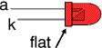 | Connect the correct way round.  The diagram may be labelled a or + for anode and k or - for cathode; yes, it really is k, not c, for cathode! The cathode is the short lead and there may be a slight flat on the body of round LEDs.
7 | Transistors | 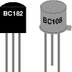 | Connect the correct way round.  Transistors have 3 'legs' (leads) so extra care is needed to ensure the connections are correct.  Easily damaged by heat.
8 | Wire Links between points on the circuit board. | single core wire | Use single core wire, this is one solid wire which is plastic-coated.  If there is no danger of touching other parts you can use tinned copper wire, this has no plastic coating and looks just like solder but it is stiffer.
9 | Battery clips, buzzers and other parts with their own wires |  | Connect the correct way round.
10 | Wires to parts off the circuit board, including switches, relays, variable resistors and loudspeakers. | stranded wire | You should use stranded wire which is flexible and plastic-coated.  Do not use single core wire because this will break when it is repeatedly flexed.
11 | ICs (chips) | 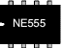 | Connect the correct way round.  Many ICs are static sensitive.  Leave ICs in their antistatic packaging until you need them, then earth your hands by touching a metal water pipe or window frame before touching the ICs.  Carefully insert ICs in their holders: make sure all the pins are lined up with the socket then push down firmly with your thumb.
Top of page | How to Solder | Advice for Components | What is Solder? | Desoldering | First Aid

What is solder?
Solder is an alloy (mixture) of tin and lead, typically 60% tin and 40% lead. It melts at a temperature of about 200°C. Coating a surface with solder is called 'tinning' because of the tin content of solder. Lead is poisonous and you should always wash your hands after using solder.
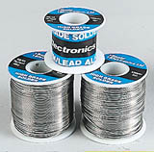
Reels of solder
Photograph © Rapid Electronics
Solder for electronics use contains tiny cores of flux, like the wires inside a mains flex. The flux is corrosive, like an acid, and it cleans the metal surfaces as the solder melts. This is why you must melt the solder actually on the joint, not on the iron tip. Without flux most joints would fail because metals quickly oxidise and the solder itself will not flow properly onto a dirty, oxidised, metal surface.
The best size of solder for electronics is 22swg (swg = standard wire gauge).

Desoldering
At some stage you will probably need to desolder a joint to remove or re-position a wire or component. There are two ways to remove the solder:
1. With a desoldering pump (solder sucker)
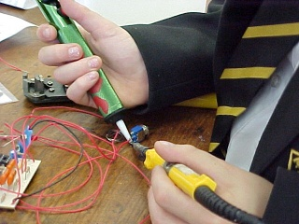
Using a desoldering pump (solder sucker)
- Set the pump by pushing the spring-loaded plunger down until it locks.
- Apply both the pump nozzle and the tip of your soldering iron to the joint.
- Wait a second or two for the solder to melt.
- Then press the button on the pump to release the plunger and suck the molten solder into the tool.
- Repeat if necessary to remove as much solder as possible.
- The pump will need emptying occasionally by unscrewing the nozzle.

2. With solder remover wick (copper braid)
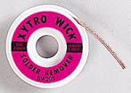
Solder remover wick
Photograph © Rapid Electronics
- Apply both the end of the wick and the tip of your soldering iron to the joint.
- As the solder melts most of it will flow onto the wick, away from the joint.
- Remove the wick first, then the soldering iron.
- Cut off and discard the end of the wick coated with solder.
After removing most of the solder from the joint(s) you may be able to remove the wire or component lead straight away (allow a few seconds for it to cool). If the joint will not come apart easily apply your soldering iron to melt the remaining traces of solder at the same time as pulling the joint apart, taking care to avoid burning yourself.

First Aid for Burns
Most burns from soldering are likely to be minor and treatment is simple:
- Immediately cool the affected area under gently running cold water.
Keep the burn in the cold water for at least 5 minutes (15 minutes is recommended). If ice is readily available this can be helpful too, but do not delay the initial cooling with cold water.
- Do not apply any creams or ointments.
The burn will heal better without them. A dry dressing, such as a clean handkerchief, may be applied if you wish to protect the area from dirt.
- Seek medical attention if the burn covers an area bigger than your hand.
To reduce the risk of burns:
- Always return your soldering iron to its stand immediately after use.
- Allow joints and components a minute or so to cool down before you touch them.
- Never touch the element or tip of a soldering iron unless you are certain it is cold.

Tools required for electronics

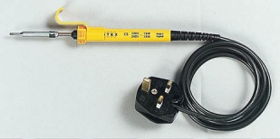
Soldering iron
For electronics work the best type is one powered by mains electricity (230V in the UK), it should have a heatproof cable for safety. The iron's power rating should be 15 to 25W and it should be fitted with a small bit of 2 to 3mm diameter.
Other types of soldering iron
Low voltage soldering irons are available, but their extra safety is undermined if you have a mains lead to their power supply! Temperature controlled irons are excellent for frequent use, but not worth the extra expense if you are a beginner. Gas-powered irons are designed for use where no mains supply is available and are not suitable for everyday use. Pistol shaped solder guns are far too powerful and cumbersome for normal electronics use.

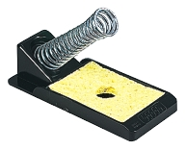
Soldering iron stand
You must have a safe place to put the iron when you are not holding it. The stand should include a sponge which can be dampened for cleaning the tip of the iron.
Photograph © Rapid Electronics

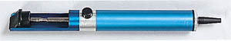
Desoldering pump (solder sucker)
A tool for removing solder when desoldering a joint to correct a mistake or replace a component.
Photograph © Rapid Electronics

Solder remover wick (copper braid)
This is an alternative to the desoldering pump shown above.
Photograph © Rapid Electronics

Reel of solder
The best size for electronics is 22swg (swg = standard wire gauge).
Photograph © Rapid Electronics

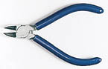
Side cutters
For trimming component leads close to the circuit board.
Photograph © Rapid Electronics

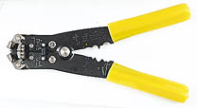
Wire strippers
Most designs include a cutter as well, but they are not suitable for trimming component leads.
Photograph © Rapid Electronics

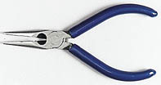
Small pliers
Usually called 'snipe nose' pliers, these are for bending component leads etc. If you put a strong rubber band across the handles the pliers make a convenient holder for parts such as switches while you solder the contacts.

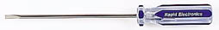
Small flat-blade screwdriver
For scraping away excess flux and dirt between tracks, as well as driving screws!
Photograph © Rapid Electronics

Heat sink
You can buy a special tool, but a standard crocodile clip works just as well and is cheaper.
Photograph © Rapid Electronics

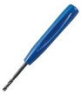
The following tool is only required if you are using stripboard:

Track cutter
A 3mm drill bit can be used instead, in fact the tool is usually just a 3mm drill bit with a proper handle fitted.
Photograph © Rapid Electronics

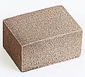
The following tools are only required if you make your own PCBs:

PCB rubber
This is an abrasive rubber for cleaning PCBs. It can also be used to clean stripboard where the copper tracks have become dull and tarnished.
Photograph © Rapid Electronics

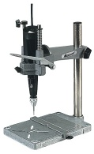
Small electric drill
Ideally this should be mounted in a drill stand. You will need a range of small drill bits, but for most holes a 1mm bit is suitable. Larger holes can be drilled with a hand drill but 1mm bits are too fragile to use reliably in a hand drill.

Starter kit of components
If you are new to electronics and would like to try adapting published projects, or designing and building your own circuits, you need to have a small stock of components available. However, there is a very wide range of components and it can be difficult to know which ones you really need! I hope the list below will help you choose a sensible selection which is within your budget. Remember that circuits built on breadboard can be dismantled after use and the components re-used.
It is usually cheapest to buy components by mail order and several suppliers are listed on the Links page. Send for a catalogue first, even if you have to pay for it, because most include a great deal of useful information as well as listing part numbers and prices. Kits of assorted components may be available and this is a great way to start if you can afford the initial cost. Remember that you will need to organise storage of the components!

Essential components
These are the components used in most projects. The individual components are quite cheap, but the total cost of the set will be significant! One way to spread the cost is to add a few items from this list every time you buy the components for a particular project. Click on the titles for further information.

Resistors
0.25W carbon film resistors are the cheapest type. Choose ones with 4-band colour codes because these are easier to read (the precision of 5-band codes is unnecessary).
Ideally you need a good selection of values over the range 100 to 1M such as the E6 or E12 series, but that is a large number of resistors! As a minimum I suggest: 470*, 1k*, 2k2, 4k7, 10k*, 22k, 33k, 47k, 100k, 220k, 470k and 1M. Buy at least 10 of each value and 20 of those marked *. The 470 resistors are for use with LEDs, even if a project specifies a slightly different value.
Resistors may be combined in series and parallel to obtain extra values, for example 100k and 220k in series is 320k which is close enough to 330k.

Capacitors
Low values: 0.01µF and 0.1µF metallised polyester, 10 of each.
High values: 1µF 63V, 10µF 25V, and 100µF 25V electrolytic with radial leads, 10 of each; 220µF 25V and 470µF 25V electrolytic with axial leads, 3 of each.

Diodes
1N4148 signal diode and 1N4001 rectifier diode, 5 of each.


LEDs
Red, yellow and green 5mm standard LEDs, 10 of each.

Transistors
About 5 general purpose, low power, NPN transistors. These should have a maximum collector current (Ic max) of 100mA, and a minimum current gain (h_{FE} min) of 200.
For example: BC548B (BC108 equivalent).
About 5 general purpose, medium power, NPN transistors. These should have a maximum collector current (Ic max) of 1A, and a minimum current gain (h_{FE} min) of 30.
For example: BC639 (BFY51 equivalent).

Integrated circuits ('chips') and holders
NE555 timer IC, at least 3 (10 if you plan to solder projects). It is not worth ordering other ICs at this stage unless you know they are needed for some of the projects you wish to try.
If you are planning to solder circuits on stripboard or PCB you will also need 8-pin, 14-pin and 16-pin DIL sockets (IC holders), at least 10 of each.

Variable resistors
Presets are cheaper than standard variable resistors but most have pins which are too large for breadboards. For breadboard circuits is is probably best to buy standard variable resistors and solder short single core 1/0.6mm wires onto them.
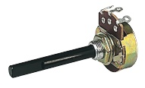
Standard Variable Resistor
Photograph © Rapid Electronics
The useful values are: 10k LIN, 100k LIN and 1M LIN, buy 2 of each. A 1M LOG potentiometer is useful too. Knobs are optional because it is easy to turn the spindles by hand. If you buy presets the horizontal style are best, all presets are LIN.

Battery clips
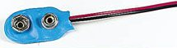
Photograph © Rapid Electronics
Clip for a 9V PP3 battery, buy 3 (or 10 if you plan to solder projects). Remember to buy a battery too!

Wire
Red and black 7/0.2mm stranded wire, one colour of single-core 1/0.6mm wire, 10m (or a reel) of each. If you are planning to build projects on breadboard buy extra colours of the single-core wire, including red and black.

Crocodile clips
Buy at least one standard crocodile clip to use as a heat sink when soldering. Miniature red and black crocodile clips (buy about 10 of each) are useful for making your own test leads using 7/0.2mm stranded wire.
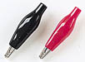
Photographs © Rapid Electronics

Switches
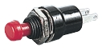 | 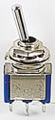
Switches are not essential for breadboard circuits because you can make or break links with pieces of wire. The on/off switch from soldered projects can also be omitted if you are willing to unclip the battery instead.
If you wish to buy a few switches the most useful types are push-to-make and miniature SPDT toggle switches, 3 of each.

Stripboard
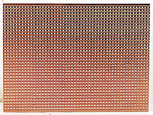
Photograph © Rapid Electronics
Buy a large sheet (or two) and cut it up as required. You can cut it neatly to size using a junior hacksaw, cutting along the lines of holes is easiest. For quickness you can break it over the edge of a workbench along the lines of holes - take care though because this needs a fairly large force and the edges will be rough. You may need to use a large pair of pliers to nibble away any jagged parts.
Avoid handling stripboard that you are not planning to use immediately because sweat from your hands will corrode the copper tracks and this will make soldering difficult unless you clean the board first.

Breadboard
Photograph © Rapid Electronics
A small breadboard (such as the Protobloc 1 shown in the picture) is suitable for simple circuits with up to two ICs, but if you intend to build more complex circuits such as counters it is best to buy a larger breadboard (such as the Protobloc 2).
Breadboards do not require soldering so the components used on them can be re-used many times. They are ideal for testing your own circuit designs and trying out ideas such as adapting a published project.

Other components to consider
Buy these if you can afford them, or wait until they are needed for a project.
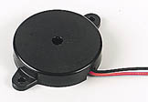
Miniature piezo transducer
Photograph © Rapid Electronics
- A light dependent resistor (LDR), ORP12 or NORPS12.
- A thermistor, miniature disc type, NTC about 5k@25°C.
- A piezo transducer with flying leads.
- A buzzer or bleeper.
- A miniature loudspeaker 8.

Storage systems for components
You can store all your components in a single container, such as a plastic food box, but as you accumulate more items it will become increasingly difficult to find the smaller components! A cheap solution is to organise the parts into small snap-top plastic bags which can be labelled, in fact you may find that some components are supplied like this.
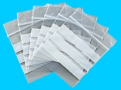
Snap-top plastic bags
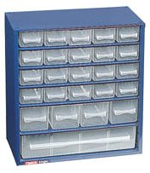
Drawer cabinet
Photographs © Rapid Electronics
Probably the best storage system is a cabinet of plastic drawers. These can be expensive, but you do not need many drawers because there is no need to have a drawer for every single component value. Many parts can be grouped together, such as decades of resistor values. For example you could organise a 15-drawer cabinet like this:
- Resistors 10+ (third band black) only a few, but they tend to be large
- Resistors 100+ (third band brown)
- Resistors 1k+ (third band red)
- Resistors 10k+ (third band orange)
- Resistors 100k+ (third band yellow)
- Resistors 1M+ (third band green) and 10M (third band blue)
- Presets, also variable resistors if they will fit in the drawer
- Capacitors low values, less than 1µF
- Capacitors electrolytic 1µF+
- Diodes and transistors
- LEDs and lamps (also LED clips and lampholders)
- ICs (chips) and their holders (DIL sockets)
- Switches and relays
- Connectors (crocodile clips, plugs and sockets)
- Other components (battery clips, piezo transducers, LDRs, thermistors)

Making a workbench for electronics

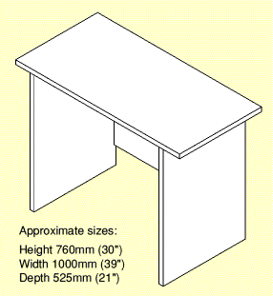
Constructing projects at home
If you are constructing electronic projects at home it can be difficult to find a suitable place to work. The dining table is certainly NOT suitable without some form of protection! You will also need a convenient socket for your soldering iron and most homes have them near the floor which is too far away. Remember the flooring material, this can be damaged by molten solder dropped off your iron.
One solution is to make your own workbench from a relatively cheap material such as white-faced chipboard (usually called 'furniture panel'). A socket for your soldering iron can be provided behind your workbench by using an extension lead with a 4-way socket which can be fixed to a wall.
If you have to work on an ordinary table protect its surface by working on a wooden board (an old drawing board is ideal) but you will need to put a soft cloth under the board to prevent it scratching the table.

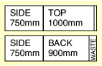
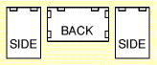
Making a workbenchThis section shows how to make your own workbench from two 1820mm (6') lengths of white-faced chipboard 'furniture panel'. This is available in various widths: 525mm (21") is probably the best to form the depth of the workbench, but you may prefer 450mm (18") or 600mm (24"). Wood-effect finishes are available at a higher cost. The pieces are held together with joint blocks to make construction easy.
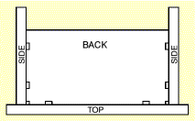
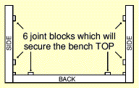
The height is suitable for use with a desk chair or dining chair, but none of the dimensions are critical so you can adapt the size to suit the space you have available. The workbench can double as a desk for homework if necessary!
Materials:
- 2 × 1820mm (6') lengths of furniture panel,
525mm (21") wide is probably the best size.
- 10 × joint blocks and suitable screws.
- Iron-on edging strip for panels (two widths).
Instructions:
- Cut the panels
The drawing shows how to cut them from two 1820mm panels.
The measurements are not critical, so you can adapt them to suit the length of material and the space you have for the completed bench. However, make sure that the two sides are identical!
- Fit the joint blocks
Screw the 10 joint blocks flush to the edges of the panels as shown.
Note that the back is a vital part of the structure, not an optional extra!
- Assemble the sides and back
Put the back down on a flat surface and join the two sides to it.
Take care to ensure that the top edges (with the unused joint blocks) are flush.
- Add the bench top
Put the bench top on the floor with its best side down, then attach the sides and back.
- Finally, apply edging strips
Turn the bench over so it is the correct way up and apply two strips of iron-on edging to the cut ends of the bench top. Use a domestic laundry iron for this, not a soldering iron. Use a knife (take care!) to trim the strips. !

Links toElectronics Sites

RSH Electronics supply kits for all the projects on this website. If you are new to electronics I recommend buying a kit because it is a good way to be sure you have the correct parts. They also stock a wide range of components and their website is easy for beginners to use.

Electronics in Meccano is an excellent site to browse if you want to learn about electronics, even if you are not interested in Meccano!

Rapid Electronics sell electronics components, project kits, tools and books. Rapid Education has valuable educational resources which may be downloaded free of charge.

Magenta Electronics stock electronics components and kits.

Maplin Electronics sell electronics components and kits.

Quasar Electronics stock a wide range of electronics kits and projects.

Bowood Electronics stock a wide range of electronics components.

Electronix Online stock a wide range of electronics components.

Boss Enclosures is a designer and manufacturer of housings in plastics and metal.

Digital-Meters.com supply a wide range of test and measurement instruments including digital multimeters.

Sir-Kit Electronics supplies home study kits at pocket money prices to help people studying for GCSE Electronics.

School Electronics has system module designs for projects, revision notes and many useful electronics links.

Electronics in Schools has links to teaching resources and advice for teachers planning to introduce electronics in their school.

Electronics Tutorials covers topics required for GCSE, AS and A level Electronics.

GCSE Electronics on MSN is a site by A Kinsey for students preparing for GCSE examinations in Electronics. The site includes a list of revision topics with links to relevant pages on this site.
AS Electronics on MSN is another site by A Kinsey. It has a number of topics which are not covered by this site, for example Boolean Algebra and a summary of equations for AS Electronics.

Doctronics has modestly-priced kits for sale and an on-line electronics textbook.

Everyday Practical Electronics is one of the best magazines for beginners with a wide range of projects and educational articles.
This site includes a basic soldering guide.

Elektor magazine includes a wide range of projects and in-depth technical articles about recent developments in electronics. The publishers also produce the i-TRIXX e-zine covering topics such as computers, internet and DIY electronics.

Bernard Babani publish modestly priced paperback books about electronics. Their range includes project books for beginners as well as reference books for experienced constructors.

Radio-Electronics.Com has free tutorials, information, data and articles about radio and electronics, also books about electronics by Ian Poole.

Electronics and Radio Today is a new site by Ian Poole designed for those with less experience of electronics. It covers basic components, analogue circuits, logic circuits, radio, ham radio, construction techniques and much more.

Discover Circuits is a large collection of electronic circuits and schematics (circuit diagrams) in many categories. Compiled by David A Johnson.

DatasheetArchive.com supplies free datasheets and information for electronic components, especially for obsolete and discontinued parts.

Datasheets.org.uk provides free datasheets, cross-reference information and a comprehensive price guide for electronic components.

DatasheetCatalog.com is a good site to search for component datasheets.

The Scots Guide to Electronics is a wide-ranging guide to electronics with many pages suitable for beginners, such as the section on components. The site is maintained by Jim Lesurf, a reader at the University of St Andrews.

Tony's Website by Tony van Roon has tutorials on various electronics topics, including the 555 timer. The site includes project ideas in the 'Electronic Circuits for the Hobbyist' section.

British Amateur Electronics Club Archive - an archive site of old British Amateur Electronics Club (BAEC) scanned and OCRed Newsletters, PicZone, Articles and useful reviews and links, including topics such as operational amplifiers and an introduction to SCART.

PICAXE - an excellent way to learn about and use Programmable Integrated Circuit microcontrollers (PICs). The programming software is available to download free of charge and no specialist equipment is required other than a low-cost download lead. The site includes extensive documentation with clear instructions for beginners, making the system ideal for education and users at home.

Electronics 2000 has a beginners guide to project building, technical data, interactive formulae calculators and software downloads, including an Electronics Assistant program.

Beginners and Intermediate Electronics is a course written by Graham Knott.

Lessons in Electric Circuits is a free series of textbooks on electricity and electronics by Tony R Kuphaldt.

Control and Embedded Systems is a more advanced site by Joe Reeder covering the use of computers to control devices such as motors and lights.

GCSE.com has a large section on Physics with many pages relevant to electronics covering topics such as voltage, current, Ohm's law, resistors and batteries.

101science.com includes educational pages about electronics.

New Railway Modellers has information and advice for model railway beginners. The pages on electronic projects include a stripboard layout for our Level Crossing Lights project.

Model Electronics Railway Group promotes interest in the application of electronics to all aspects of railway modelling. The website includes tutorials for beginners.
http://www.electronics-project-design.com/MicrocontrollerProject.html
www.kpsec.freeuk.com

