Simple Line Following Robot
Introduction: -
We all would like to have the robot do some work for us, here is a simple circuit that will help you to develop a White Line follower on a Black smooth surface.

Block Diagram: -
Without wasting much time, lets get to the circuit diagram of the robot. Remember this design needs just your basic know how of the Transistor and the DC motor working.
Refer Figure 1 – Block Diagram. Our circuit consits of 3 blocks. An input (coming from the sensor), the amplifer block and the motor driver. Actually the amplifier and the motor driver use the same transistor.

Left
Sensors
Signal Amplifier
For left sensors
Right DC motor

Right
Sensors
Signal Amplifier
For right sensors
Left DC motor

Figure 1: - Block Diagram

Circuit Diagram: -
The circuit diagram is shown in Figure 2. Lets see each component in brief.
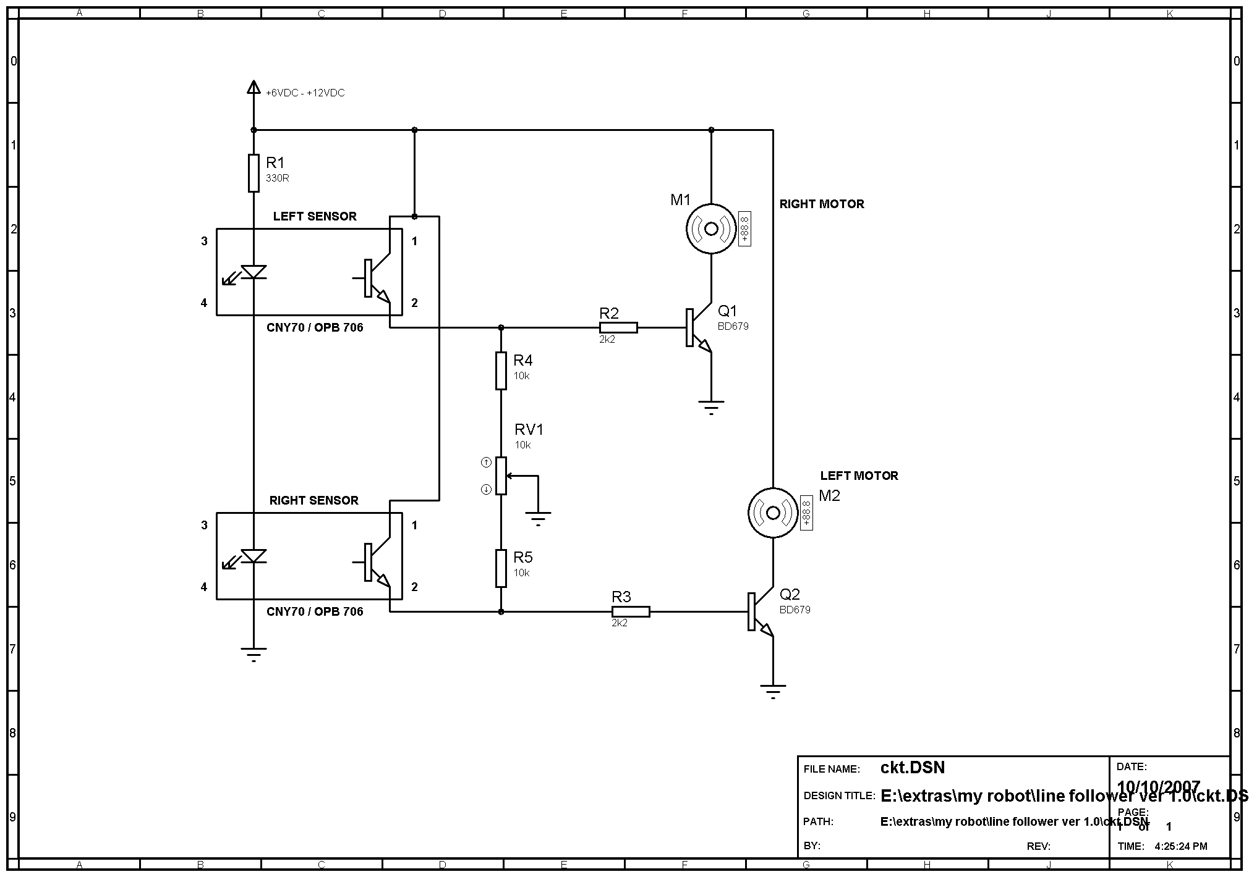
Figure 2: - Circuit Diagram

Sensors: -
The sensors we are using in this robot are the OPB 706 or CNY 70. The sensors consist of the IR LED and the Photo Transistor in the same module. The output from the Photo transistor is directly fed to the base of the transistors Q1 and Q2. The output at the emitter of Sensors will be depending on the amount of light that is being reflected and collected by the base of the photo transistors.
The Amplier: -
We are using the BD679, darlington pair power transistors that are also driving the DC motors. The bridge formed by the resistors R4, R5 and RV1 is used to adjust the balance between the two motor speeds. By varying the preset of RV1 we can adjus the sensitivity of the sensors, i.e. the current that will be flowing to the base of Q1 and Q2 is being controlled.
Motors: -
To avoid more expenses on getting the very sophistocated DC motors, we shall use in the robot the motors, and necessarily the gear box to have a little more torque. Also the speed of the DC motor should be reduced using the gear box, if the motor speed is high, the robot will fail to follow the white line. The motors used are from a toy crane.

