OSD Telemetry Module: PRM-02
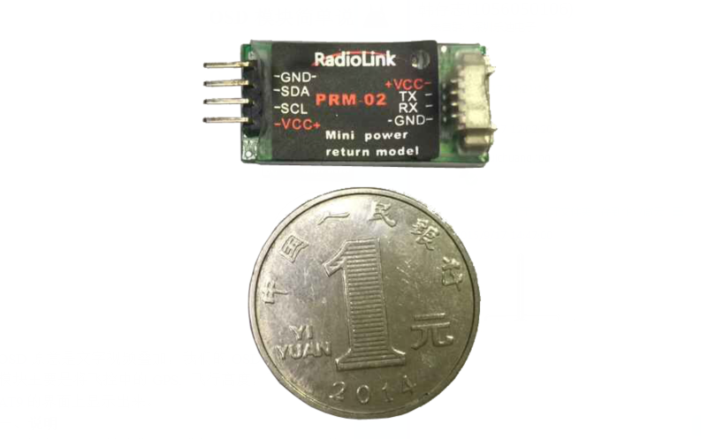
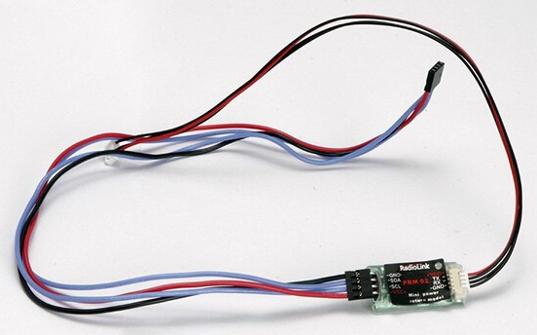
OSD telemetry sensor: PRM-02
OSD Telemetry module transmits the data from the flight controller and shows the data of SPEED, RISE, THRO, VOLT, LATI, LONG, ALT, GPS, RSSI, MODE, YAW, ROLL, PITC, DIST in the display screen of AT9 or AT10.
Size: 33*15mm
Weight: 6g (including connector)

- Introduction:
- . Please upgrade your AT9 firmware to V1.2.6(OSD), AT10 firmware to V1.0.6(OSD).
- . So far, this OSD telemetry module is compatible with PIX and APM.
- . OSD telemetry module can work with both R9DS and R10D.

- Connection
Connect one end of the OSD to R9DS or R10D, and the other end to PIX or APM.
Connect to PIX.
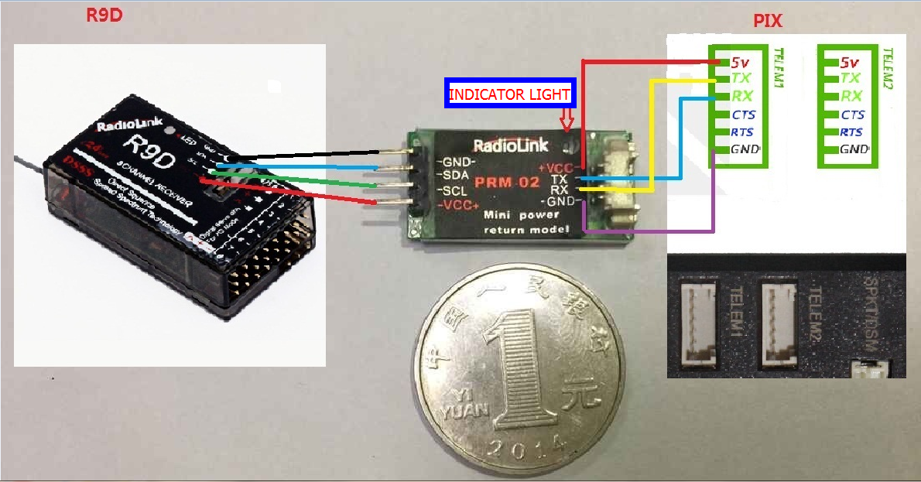

Connect to APM.
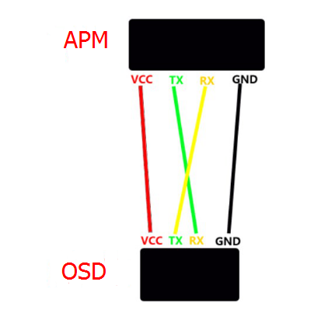
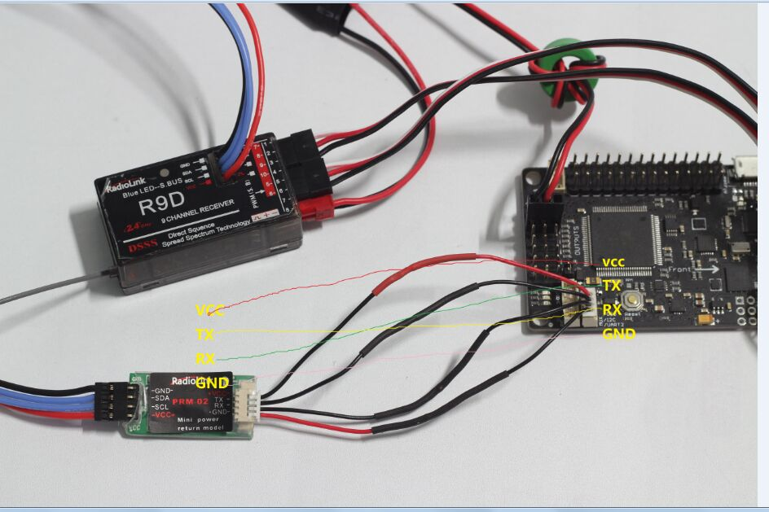

3. Displaying effect(AT9)
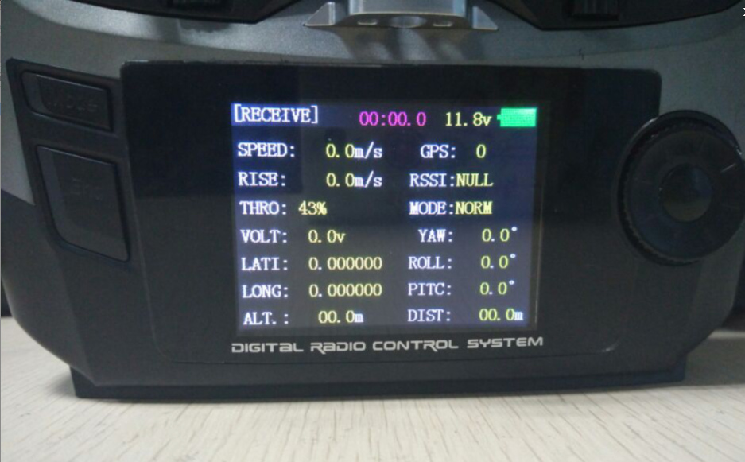

Displaying effect(AT10)
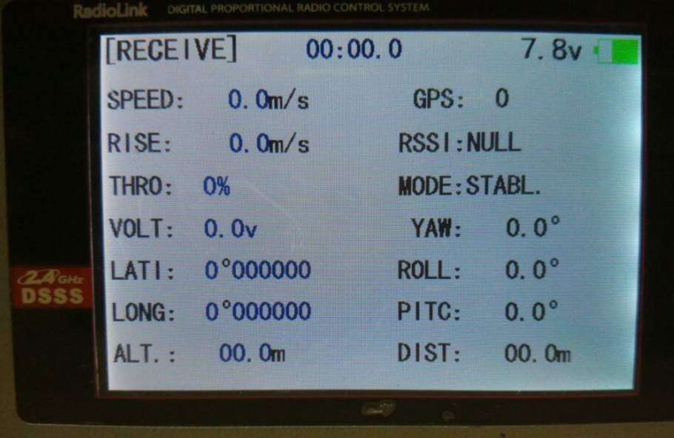

Attention
- No output if USB connect flight-controller and computer.
- No VOLT information if use UBEC, have to offer electricity for flight-controller by volt ammeter.
- Have to short-circuit the MUX-TXO/OSD of APM when connect PRM-02(OSD) to APM.

