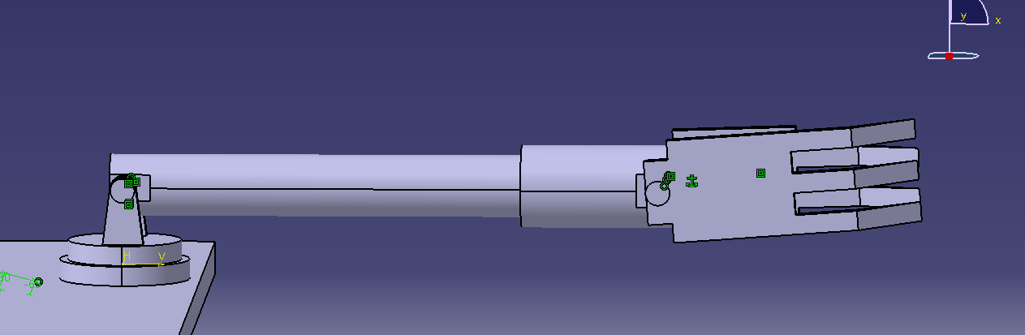  
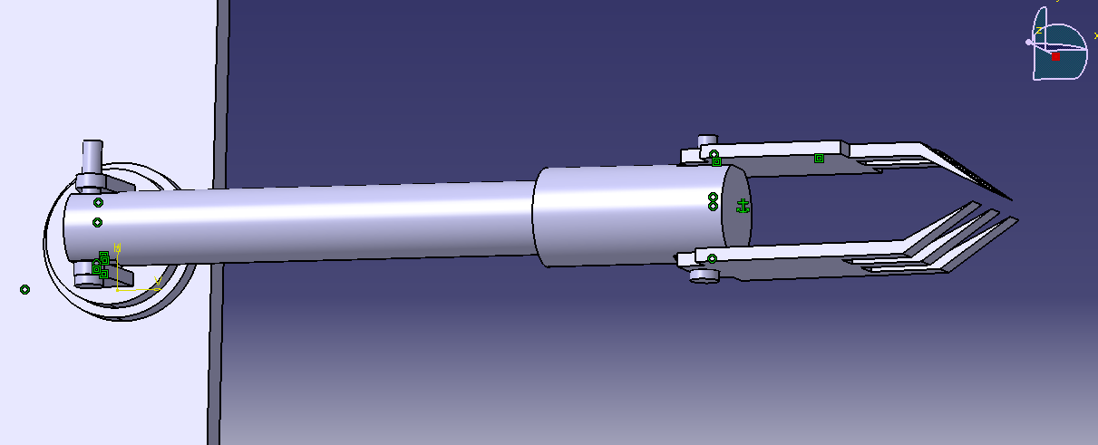

Total length of arm (approx.) = 500mm.

Length of fore arm(approx.) =370mm.

Length of gripper(approx.) =150mm.

Approximate weight of groundnut plant with pods, soil 2.6 kg.

Motions required:

1. Gripper movement for plucking/grip the plant.
2. Rotation of wrist 360 degree. (Rolling)
3. Arm movement up to 180 degrees. (pitch)
4. Arm movement up to 180 degrees. (yawing)

**Working**: Initially the robotic arm will grip & pluck the groundnut plant. The arm moves upwards & then rotate through 180 degrees.